

overnight games

FYP Game Design Document



[Date]

Ubisoft Entertainment

[Company address]

# Overview

## Theme / Settting / Genre

## The genre is a third person post-apocalyptic shooter (Think revisiting Chernobyl and The Last Of Us)

## Core Gameplay Mechanics

## Movement (walk, run, crouch, prone, roll)

1. Combat (Shooting with rifle, pistol, and melee weapon)

## Exploration rewards players with supplies / ammunition / storytelling / weapons

## Different weapons

## Different enemy types (Animals, humans, mutated humans)

## Player will be forced to interact with environment to advance

## Combat is an option, stealth is also an option

## Environmental storytelling

## Story

## This story is about Lt. James Pratt, a marine whose mission is to enter a nuclear facility that has leaked, extract information, and get out. However, along the way of your mission, you learn of what exactly caused the nuclear meltdown, and the fate of the people along with it.

## Truth is, the military’s tests caused the nuclear reactor to have a meltdown, dooming everyone in the facility, and the entire town that surrounds it. As the player goes through the game, environmental storytelling will paint a clearer picture of how the innocent civilians were trapped inside, prevented from escaping.

## Influences

## The Last of Us

## Metro Last Light Redux

## Chernobyl / Fukushima

## The Division

# Core Gameplay Mechanics

## Basic Movement

Player will be able to move by walking, running, proning, crawling. In combat, the player can roll away as well. Movement will be similar to Witcher 3’s controls, but plays and feels like the Division.

References: <https://www.youtube.com/watch?v=iekR_eRa4tw> (Watch 2:20:00 to 2:25:00)

## Combat

The combat will play and feel like The Last Of Us / The Division, but the actual combat will be similar to L4D2. Meaning to say, special creeps like the Tank, Charger, Hunter, will have more health than regular mobs. When the player shoots at the enemies, the only feedback will be bloodsplats that come out of their bodies. There will be no indication of how much health the enemy has and how much damage you deal.

Reference: <https://www.youtube.com/watch?v=BIeP1pXMhFc>

Note: Just observe the enemy AI’s health, that’s what we’re looking at, not the feel of the game / how it plays

## Exploration Rewards Players

The player will be rewarded for exploring places for more than just what they need to.

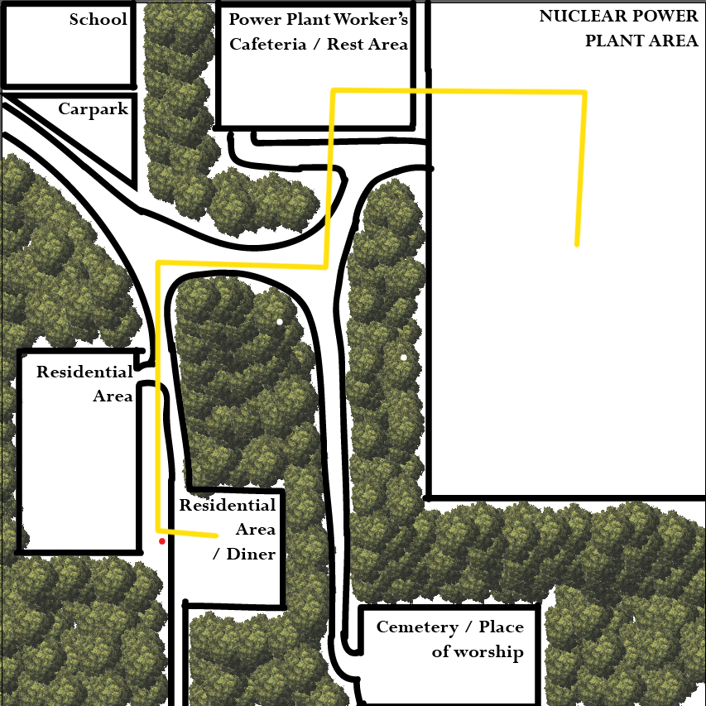

The **Golden Path** is: Residential Area / Diner -> Power Plant Worker’s Cafeteria -> Nuclear Power Plant. The school, carpark, residential area and cemetery / place of worship will be entirely optional for the player to explore.

## Different enemy types

There are different enemy types for the player to overcome.

Regular mobs:

1. Mutated Humans

Basic mobs, they take 1-2 headshots to kill. Can be distracted via sound, but also attracted to it

1. Mountain Cats

Stronger than mutated humans, they can be lured to the mutated humans. But they can also turn on you.

1. Wolves

Weaker than mutated humans and mountain cats, but they roam in packs. Very keen hearing.

1. Wallers

Mutated humans that have been “deactivated” and are basically AFK. They are activated by sound, so players must be careful when navigating inside enclosed spaces

Boss mobs:

1. Seriously mutated human

Located at the cemetery, this boss will be one-of-a-kind. The boss will tell the story of how he ended up like this, and the player will make a decision. Choose the wrong choice, and the player will be forced to kill him.

1. ???

## Environmental interactions

Environmental interactions will be an integral part of the game. For example, the player will not be able to enter the nuclear power plant area unless he or she activates the power generator at the back of the diner in the residential area. (which can be found only by exploring)

## Combat vs Stealth

The player will be able to choose between combat and stealth, this is pretty self-explanatory.

## Environmental Storytelling

## 